Google Research

Here’s how it works:

- Go to: http://docs.google.com or http://drive.google.com
- Click the red “Create” button and choose “Document.”
- Begin entering information about your subject. (In this example, I’ll pretend I’m writing a report about the Rosa Parks.)
- Highlight a key word.
- Pull down the “Tools” menu to “Research.”

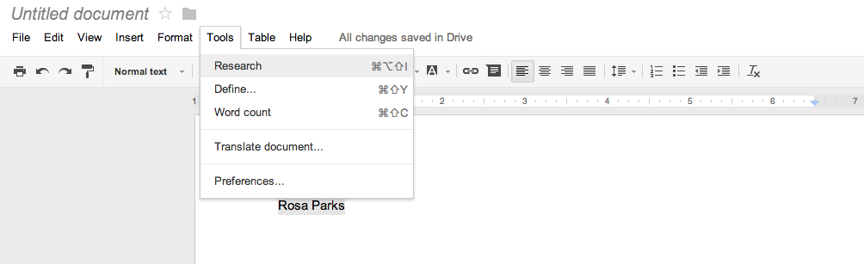
This will open a Google search area in the right sidebar of your document.
- Click the forward arrow to return to the search results.
- Use the pull-down arrow to narrow the search results.

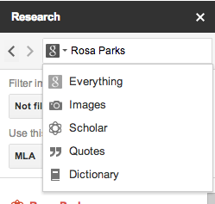
Citing the sources

Web Results:

Use buttons at the bottom of each search result to insert a link and/or cite the source of the website:
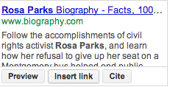
Optional - Click the back button in the sidebar and then click the “Settings” link at the bottom of the window and choose the desired citation format.

Images

Drag an image onto the screen and it will be automatically cite the source!

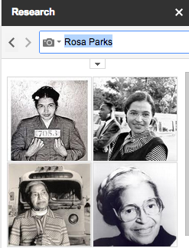
Quotes

Click to “insert” a quote and it will automatically be cited!

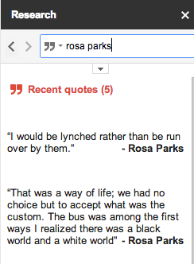

Scholar
Click the “Cite as footnote” button to do that, or click the “Insert” button to insert the citation within the document text.

Viewing the Citations / Footnotes:
Simply scroll to the bottom of the page to see the citations in the page footnote area.

