The Nazi Party
1919-1945

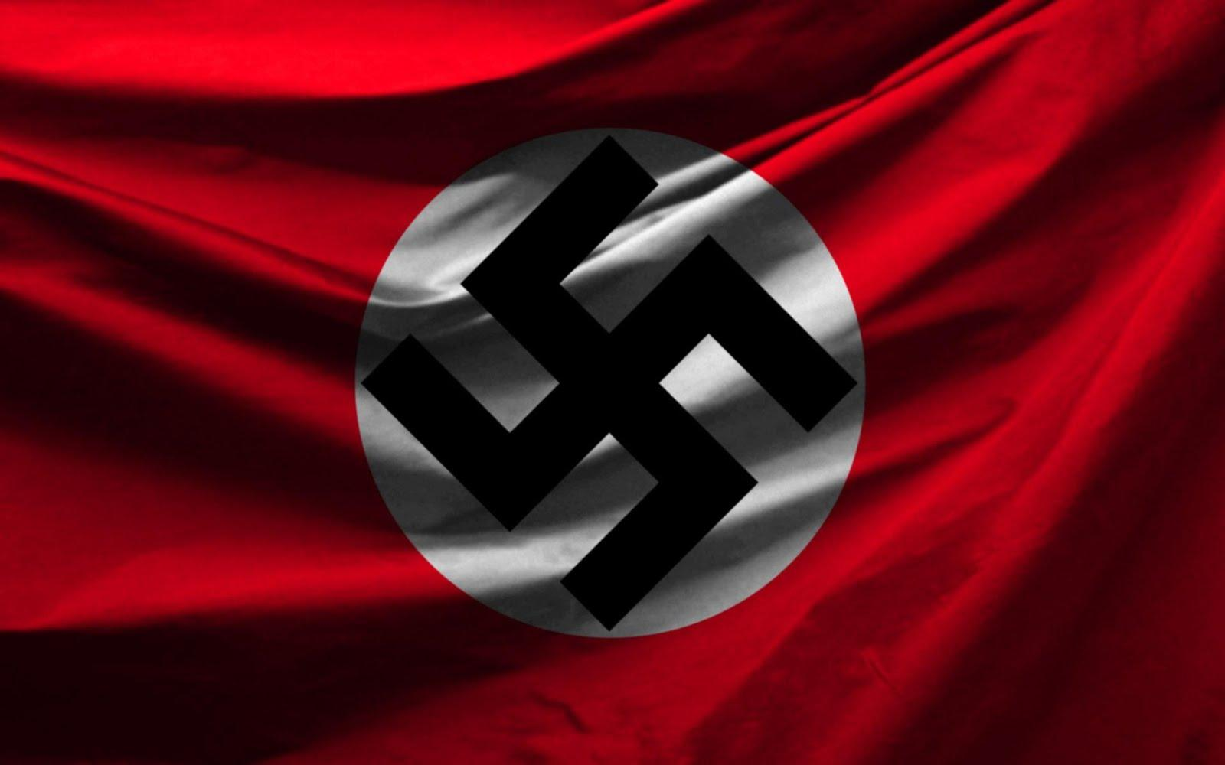

Austin W.
March 15, 2013

The Nazi party began in Germany in 1919. It began as a gang of jobless soldiers who became the legal government by 1933. In 1918, WWI ended and Germany lost. German leaders blamed leftwing politicians, Communists, and Jews for making them lose the war. They were trying to make a new government, but nobody could get things in order. The country didn’t have money or jobs and had many soldiers that were left without jobs. They started the Nazi Party to improve their national pride and build the military. The Nazi Party joined the other people that believed in a pure German race. Hitler kept putting Jews down and the German people joined him.
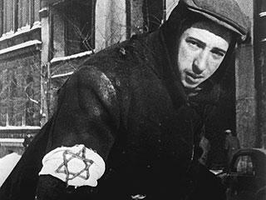
By 1920, the Nazi party had 3,000 members and a year later Hitler became their leader (Fuhrer). Three years later, Hitler tried to take over Munich but it failed. During the trail he kept talking about how the old government was bad. After the trial they sentenced him to prison for five years, but he only served for one year. While he was in prison Hitler wrote a book called Mein Kampf (My Struggle). The book was about his extreme ideas about Germany and being the toughest. He was pro-Germany, anti- Jew, and anti-communism. He supported war to make
Germany number one.

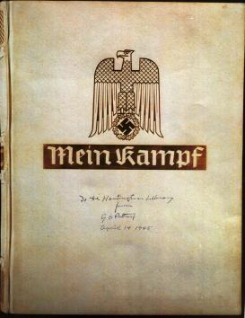
After Hitler got out of jail, he rebuilt the Nazi party. They had different groups called the SA (Military unit), SS (the special duty unit), The Hitler Youth Group (for young boys), the Student League, Pupils League and the National Socialist Woman League. The younger men of the lower middle classes liked Hitler’s ideas, so they joined the Nazi party.
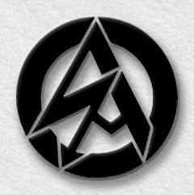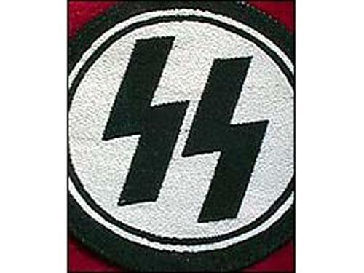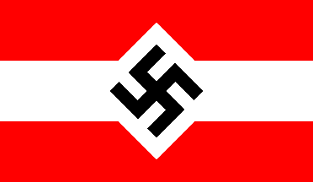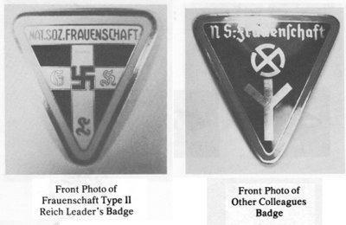
Things were getting much worse in Germany, in 1929 when the Great Depression began. Paul Von Hindenburg created a new government because the old one was falling apart. In 1932, Hindenburg didn’t want Hitler to win the presidential election, so he ran again and won even though he didn’t want to because he was eighty-four years old.
After Hindenburg was elected the economy and government were still bad. There was violence every day. Powerful German leaders tried to stop Hitler from being president, but Paul Von Hindenburg had to name Hitler chancellor on January 30, 1933.
Hitler was a dictator, which means he ruled everything and the Nazi Party got stronger. The Nazi Party controlled everything in Germany. They took over the schools, the radio and the newspapers.
They made a secret police force and created concentration camps.
Hitler designed the Nazi flag, but the swastika was used at least 5000 years before that. The word swastika comes from the Sanskrit Svastika that means “good fortune” or “well being”. It possibly stands for the movement of the sun though the sky. The swastika became the most famous part of Nazi propaganda. It was a source of pride to the Nazis but was terrifying to the Jews and other enemies of Nazi Germany.
After Germany lost the war in 1945, Hitler committed suicide and top leaders of the Nazi party were convicted of crimes against peace and against humanity. The Allies banned the Nazi party.

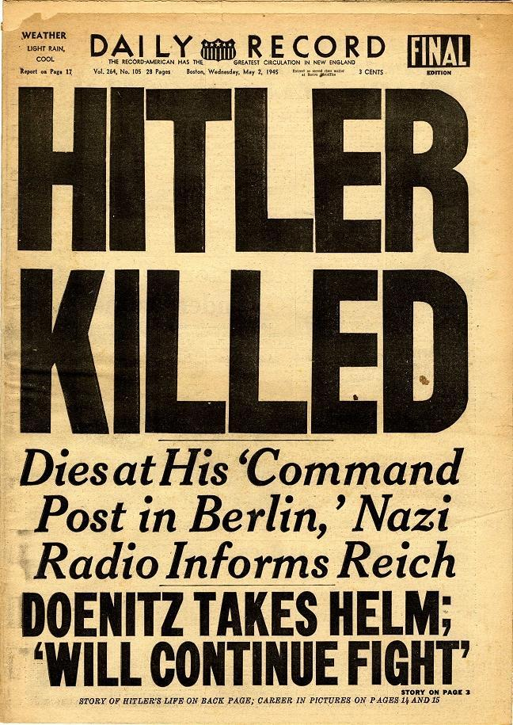

Bibliography

Downing, David. Origins of the Holocaust. Milwaukee, WI: World
Almanac Library, 2006. Print.

Staff writer. "Holocaust Timeline: The Rise of the Nazi Party." Holocaust
Timeline: The Rise of the Nazi Party. N.p., 2005. Web. 19 Mar. 2013.

Staff writer. The World Book Encyclopedia Volume 14. Chicago, IL: World
Book, 2006. Print.

Images

www.google.com/images

